FINALTERM EXAMINATION
Spring 2010
ECO401- Economics (Session - 4)

Question No: 1 ( Marks: 1 ) - Please choose one
An increase in supply is shown by:
► Shifting the supply curve to the left.
► Shifting the supply curve to the right.
Lesson # 4
► Upward movement along the supply curve.
► Downward movement along the supply curve.

Question No: 2 ( Marks: 1 ) - Please choose one
Which of the following will be TRUE if demand is inelastic?
► The coefficient of elasticity is greater than one.
► The percentage change in quantity demanded is same as the percentage change in the price.
► An increase in price will increase total revenue.
P 28
► None of the given options.

Question No: 3 ( Marks: 1 ) - Please choose one
Which of the following is regarded as a general determinant of price elasticity of demand?
► Nature of the good (luxury versus necessity).
► Availability of close substitutes.
► Share of consumer's budget and passage of time.
► All of the given options.

Question No: 4 ( Marks: 1 ) - Please choose one
Suppose there are only two goods A and B, if more of good A is always preferred to less, and if less of good B is always preferred to more, then:

► Indifference curves slope downwards.
► Indifference curves slope upwards.
► Indifference curves may cross.
► Indifference curves could take the form of ellipses.

Question No: 5 ( Marks: 1 ) - Please choose one
If a consumer’s marginal rate of substitution equals 2 eggs for 1 hamburger then:

► The consumer’s indifference curve must be positively sloped.
► The consumer’s indifference curve must be convex with respect to the origin of the graph.
► The ratio of the consumer’s marginal utility of 1 egg to that of 1 hamburger must equal ½.
► All of the given options.

Question No: 6 ( Marks: 1 ) - Please choose one
Suppose you are a workaholic (like work a lot) and your friend is a leisure lover. Compared to your friend your indifference curve will be:

► Flatter.
► Steeper.
► Identical.
► None of the given options.

Question No: 7 ( Marks: 1 ) - Please choose one
In economics, the “long run” is a time period in which:

► All inputs are variable.
► All inputs are paid for.
► All outputs are determined.
► All loans are repaid.

Question No: 8 ( Marks: 1 ) - Please choose one
To find the profit maximizing level of output, a firm finds the output level where:
► Price equals marginal cost.
► Marginal revenue and average total cost.
► Price equals marginal revenue.
► None of the given options.

The profit maximizing level of output is found by equating its marginal revenue with its marginal cost, which is the same profit maximizing condition that a perfectly competitive firm uses to determine its equilibrium level of output. Indeed, the condition that marginal revenue equal marginal cost is used to determine the profit maximizing level of output of every firm, regardless of the market structure in which the firm is operating.

Question No: 9 ( Marks: 1 ) - Please choose one
A perfectly competitive firm maximizes profit by finding the level of production at which:

► Price = Marginal Cost.
► Price = Average Total Cost.
► Average Total Cost = Marginal Cost.
► Price < Marginal Cost.

Question No: 10 ( Marks: 1 ) - Please choose one
In the short run, a firm should shut down when:

► Production losses are less than fixed costs.
► Only normal profits are earned.
► Production losses exceed fixed costs.
► Fixed costs are zero.

Question No: 11 ( Marks: 1 ) - Please choose one
Loud music from a neighbor's party is:

► A negative externality whether or not you like it.
► A positive externality whether or not you like it.
► A positive externality if you like the music and a negative externality if you don't.
► A negative externality if you like the music and a positive externality if you don't.

Question No: 12 ( Marks: 1 ) - Please choose one
Classical economics was replaced as the dominant theory of macroeconomic analysis by:

► Monetarism.
► Rational expectations.
► Keynesian economics.
► Neoclassical economics.

Question No: 13 ( Marks: 1 ) - Please choose one
Unemployment benefits may increase the unemployment rate because:

► Unemployment benefits reduce the cost of job search.
► Unemployment benefits encourage people to quit their jobs.
► Unemployment benefits reduce the benefits of additional job searching.
► Unemployment benefits enable people to quit searching for work.

Question No: 14 ( Marks: 1 ) - Please choose one
Naima has just finished her school job and is waiting to report to new job at the beginning of the month. Naima is considered to be:

► Cyclically unemployed.
► Employed.
► Structurally unemployed.
► Frictionally unemployed.

Question No: 15 ( Marks: 1 ) - Please choose one
Which of the following is a less important component of the balance of payments?

► The capital account.
► The current account.
► The financial account.
► All three components are equally important.
Reference:
http://wps.prenhall.com/bp_hubbard_econ_2/85/21856/5595147.cw/-/5595174/index.html
Question#10

Question No: 16 ( Marks: 1 ) - Please choose one
An increase in ''per capita'' national income implies that:

► Everyone in the nation is enjoying a better standard of living.
► The population has increased.
► National income has risen faster than the population has risen.
► The distribution of income has improved.
Reference:
http://www.ecoteacher.asn.au/devel2/devel2.htm

Question No: 17 ( Marks: 1 ) - Please choose one
Suppose the government increases spending. Which of the following would be part of the crowding out effect?

► Interest rate rises and investment falls.
► Interest rate rises and velocity of circulation also rises.
► Higher interest rates encourage the central bank to increase the money supply.
► Interest rate falls and exports rise.

Question No: 18 ( Marks: 1 ) - Please choose one
Real Gross National Product (GNP) is best defined as:

► The pound value of all final goods and services produced in the economy during a particular time period and measured in current prices.
► The pound value of all goods produced for final consumption by households in a particular year and measured in constant prices.
► The current pound value of all new and used goods produced and sold in the economy during a particular time period.
► The market value of all final goods and services produced by the economy during a given time period, with prices held constant relative to some base period.

Question No: 19 ( Marks: 1 ) - Please choose one
The news on the television reports that the dollar has strengthened relative to the Japanese yen. This means that:
► The dollar can now purchase more yen.
► The US trade balance with the Japanese economy has improved.
► The yen can now purchase more dollars.
The exchange rate increases (i.e., a unit of your currency is worth more in foreign currency than previously), the currency is said to have strengthened, appreciated, or increased in value (revaluation). For example, assume that the exchange rate between the U.S. dollar and the Japanese yen changed from US$1=104 yen to US$1=110 yen. This would strengthen the value of the U.S. dollar in that you would receive more yen in exchange for your dollar

► The dollar has depreciated relative to the yen.

Question No: 20 ( Marks: 1 ) - Please choose one
The Marginal Propensity to Save (MPS) is:

► One Minus Marginal Propensity to Consume (MPC).
► Saving divided by consumption.
► The slope of the consumption function (or line).
► The proportion of disposable income used for consumption.

Question No: 21 ( Marks: 1 ) - Please choose one
Which of the following is true about supply curve under monopoly?
► It is same as the competitive market supply curve.
► It is the portion of marginal cost curve where marginal costs exceed the minimum value of average variable costs.
► It is the result of market power and production costs.
► None of the given statements is true.

Question No: 22 ( Marks: 1 ) - Please choose one
All of the following conditions lead to the successful operation of a cartel EXCEPT:
► Market demand for the good is relatively inelastic.
► The cartel supplies all of the world's output of the good.
► Cartel members have substantial cost advantages over non-member producers.
► The supply of non-cartel members is very price elastic.

Question No: 23 ( Marks: 1 ) - Please choose one
Which of the following is required to make the equation of exchange in the quantity theory of money?
► V and Q are assumed to be constant.
► The money supply is assumed to be produced by the banking system and not exclusively in currency.
► The quantity of money is assumed to determine the amount of Real GDP.
► M and P are considered constant.

Question No: 24 ( Marks: 1 ) - Please choose one
Potential Gross Domestic Product (GDP) measures the economy’s ability to produce goods and services in which of the following conditions?
► If labor force is fully employed.
► If price level is stable.
► If trade balance is zero.
► If federal budget is balanced.

Question No: 25 ( Marks: 1 ) - Please choose one
Which of the following specifies the maximum amount of a good that may be imported in a given period of time?
► Trade restriction.
► Quota.
► Import restriction.
► Legislative restriction.

Question No: 26 ( Marks: 1 ) - Please choose one
GNP is a good indicator of:
► The total payment of factor owners.
► The amount of consumption and investment.
► The conditions of production and employment.
► The amount of incomes available for spending.

Question No: 27 ( Marks: 1 ) - Please choose one
The demand for factors of production is derived from:
► Money market.
► Goods market.
► Stock market.
► Financial market.

Question No: 28 ( Marks: 1 ) - Please choose one
Labor supply curve is backward bending because:
► The income effect of higher income dominates the substitution effect of higher wages.
► The substitution effect of higher income dominates the income effect of higher wages.
► The income effect of higher income dominates the price effect of higher wages.
► None of the given options.

Question No: 29 ( Marks: 1 ) - Please choose one
The discounted value of the net returns that the asset generates over a period of time plus the discounted value of its disposal value at the end of the period minus the initial purchase cost is known as:
► Future value.
► Net present value.
► Discounted value.
► Disposal value.

Question No: 30 ( Marks: 1 ) - Please choose one
Information products are also known as:
► Inferior products.
► Superior products.
► Internet products.
► Expensive products.

Question No: 31 ( Marks: 1 ) - Please choose one
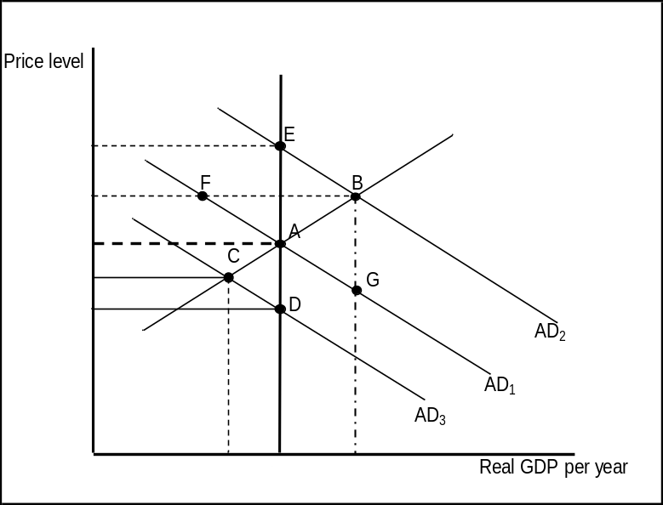
Refer to the above figure, suppose that the economy is in long-run equilibrium at point A. Now suppose the stock market crashes, significantly reducing household wealth. What happens in the short-run?
► Real GDP remains at Y₁ but the price level falls to P₃.
► The quantity of real GDP demanded falls resulting in a movement from point A to point F.
► Real GDP decreases from Y₁ to Y₃ and the price level falls from P₁ to P₃.
► The economy moves to a short-run equilibrium at point D.

Question No: 32 ( Marks: 1 ) - Please choose one
Which of the following is a cost of rising unemployment?
- Output foregone.
- Unemployment compensation that must be paid.
- Rising inflation that erodes the value of money.
► I, II, and III.
► I and II.
► I and III.
► II and III.

Question No: 33 ( Marks: 1 ) - Please choose one
Rising inflation means:
► That the price level is increasing by a given percentage rate.
► That the prices of all goods and services increase from year to year.
► That the price level is rising at an increasing rate.
► That the price level is rising at a variable rate.

Question No: 34 ( Marks: 1 ) - Please choose one
Economic growth occurs by an outward shift of:
► The production possibility frontier.
► The gross domestic barrier.
► The marginal consumption frontier.
► The minimum efficient scale.

Question No: 35 ( Marks: 1 ) - Please choose one
Which of the following is a necessary condition for the high rate of modern economic growth?
► Continuous technology progress.
► High rate of population growth.
► Development of urban centers.
► Expansion of railways.

Question No: 36 ( Marks: 1 ) - Please choose one
The government has a balanced budget if:
► Its total revenues are equal to its total expenditures.
► Its total revenues are less than its total expenditures.
► Its total revenues are greater than its total expenditures.
► The money supply is less than total expenditures.

Question No: 37 ( Marks: 1 ) - Please choose one
Which of the following is the monetary policy tool that involves the buying and selling of government bonds?
► Moral suasion.
► Reserve requirements.
► The discount rate.
► Open market operations.

Question No: 38 ( Marks: 1 ) - Please choose one
When the comparative advantage in production of a good does occur?
► When a country can produce that good using fewer resources than other countries.
► When a country can produce that good at a greater opportunity cost than other countries.
► When a country can produce that good at a lower opportunity cost than other countries.
► When a country has a greater supply of natural resources required to produce that good, compared to other countries.

Question No: 39 ( Marks: 1 ) - Please choose one
A quota is defined as:
► A restriction on exports.
► A unit tax imposed on a product.
► A limit on the quantity of a good that can be exported.
► A limit on the quantity of a good that can be imported.

Question No: 40 ( Marks: 1 ) - Please choose one
Which of the following statements is TRUE about the agriculture sector in low income countries?
► The agricultural sector has been decreasing in size because its productive workers prefer to migrate to urban areas.
► The agricultural sector is by far the largest producer and the most productive sector in low-income countries.
► Although the agricultural sector is the largest employer, labor’s productivity in this sector is very low.
► The agricultural sector has been increasing in size and in terms of labor productivity as rural farmers increasingly start to mechanize.

Question No: 41 ( Marks: 1 ) - Please choose one
Production possibilities curve will shift downward if there is:
► Immigration of skilled workers into the nation.
► An increase in the size of the working-age population.
► A decrease in the size of the working-age population.
► Increased production of capital goods.

Question No: 42 ( Marks: 1 ) - Please choose one
Suppose the total costs of first four units of an output produced are 10, 20, 30, and 40 respectively. What is the marginal cost of the fourth unit of output?
► 10.
► 20.
► 30.
► 40.

Question No: 43 ( Marks: 1 ) - Please choose one
If marginal revenue is Rs. 15,000 and marginal cost is Rs. 20,000. The firm should:
► Expand output.
► Do nothing without information about your fixed costs.
► Expand output until marginal revenue equals zero.
► Reduce output until marginal revenue equals marginal cost.

Question No: 44 ( Marks: 1 ) - Please choose one
The average annual income per head for all the inhabitants of the country is known as:
► Gross domestic product.
► Gross national product.
► Net national product.
► Per capita income.

Question No: 45 ( Marks: 1 ) - Please choose one
Gross domestic product deflator can be obtained by dividing nominal gross domestic product with:
► Real gross domestic product.
► Gross national product.
► Net national product.
► Per capita income.

Question No: 46 ( Marks: 1 ) - Please choose one
The principle which states that a change in income causes a magnified change in investment is termed as the:
► None of the given.
► Paradox of thrift.
► Multiplier effect.
► Accelerator effect.

Question No: 47 ( Marks: 1 ) - Please choose one
If central bank increased the money supply, then what will be happen to IS curve?
► IS curve will Shifts rightward.
► IS curve will Shifts leftward.
► IS curve will remain unaffected.
► IS curve will become vertical.

Question No: 48 ( Marks: 1 ) - Please choose one
The value of world trade has increased ----------over the period of 1930-2000.
► 20 fold
► 10 fold
► 5 fold
► 14 fold

Question No: 49 ( Marks: 3 )
Write down the functions of commercial banks.

Question No: 50 ( Marks: 3 )
How the growth rate of output is determined in the exogenous growth model?

Question No: 51 ( Marks: 5 )
Why is taxation necessary? What are the principles of taxation?

Question No: 52 ( Marks: 5 )
Following figure shows the circular flow of goods and income in a two sector economy. Interpret all the points in this figure that how the household sector and business sector work in an economy to produce goods and services.
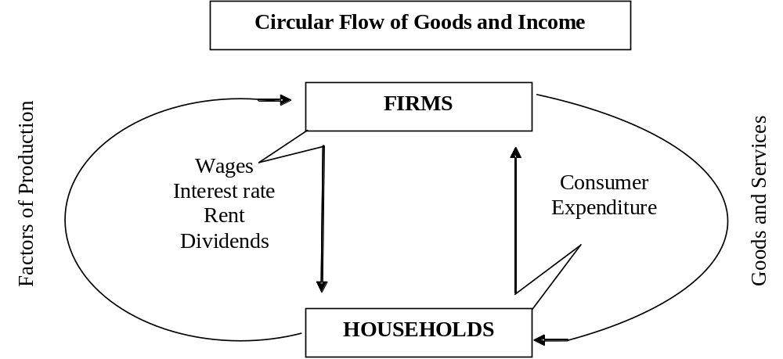

Question No: 53 ( Marks: 5 )
Explain the difference between current account and capital account.

